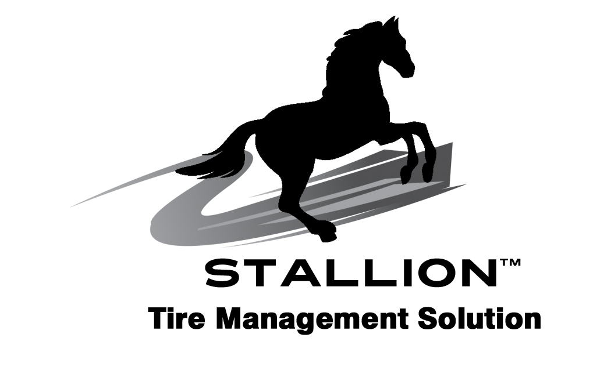



Stallion Phantom Farm Ballast is a tire pressure management solution and a tire sealant designed for OTR, farm and industrial equipment tires. Phantom Farm Ballast protects the tire casing from oxidation damage and will self seal bead/rim leaks/O-Ring leaks, minor leaks from UV damage and self-repair punctures up to 1/2 inch in diameter. Phantom Farm Ballast can also be used as tire ballast.

• Non-Hazardous• Biodegradable
• Non-Toxic• Non-Flammable

Stallion holds ARDL Accreditation.
ARDL test...Stallion Sahara is the only tire casing product that has been tested and passed by ARDL, one of the most recognized labs in the world for tire/rubber testing. The test was based on OEM test standards and
TMC RP.

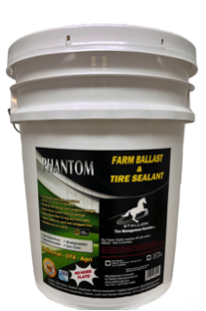

Key Features:

- Stops air loss and retains correct tire pressure by sealing the entire casing from normal casing porosity.
- Continually self-seals punctures up to ½” (1.2 cm) in diameter.
- Protects tire casing from oxidation damage.
- Operates between -10°F to 225°F
(-25°C to 107.2°C).
- Stops Bead/Rim/O-Ring and Vent leaks.
- Added safety for used and recapped tires.
- Does not block the valve system.
- Does not interfere with Retreading, Will not cause chamber fires in a retread plant. Test results available upon request.
- Approved for use with TPMS.
- Helps retain casing integrity.
- Washes out easily with water.
- DOES NOT FREEZE
- Non-Hazardous
- Non-Flammable
- Biodegradable
- Non-Toxic
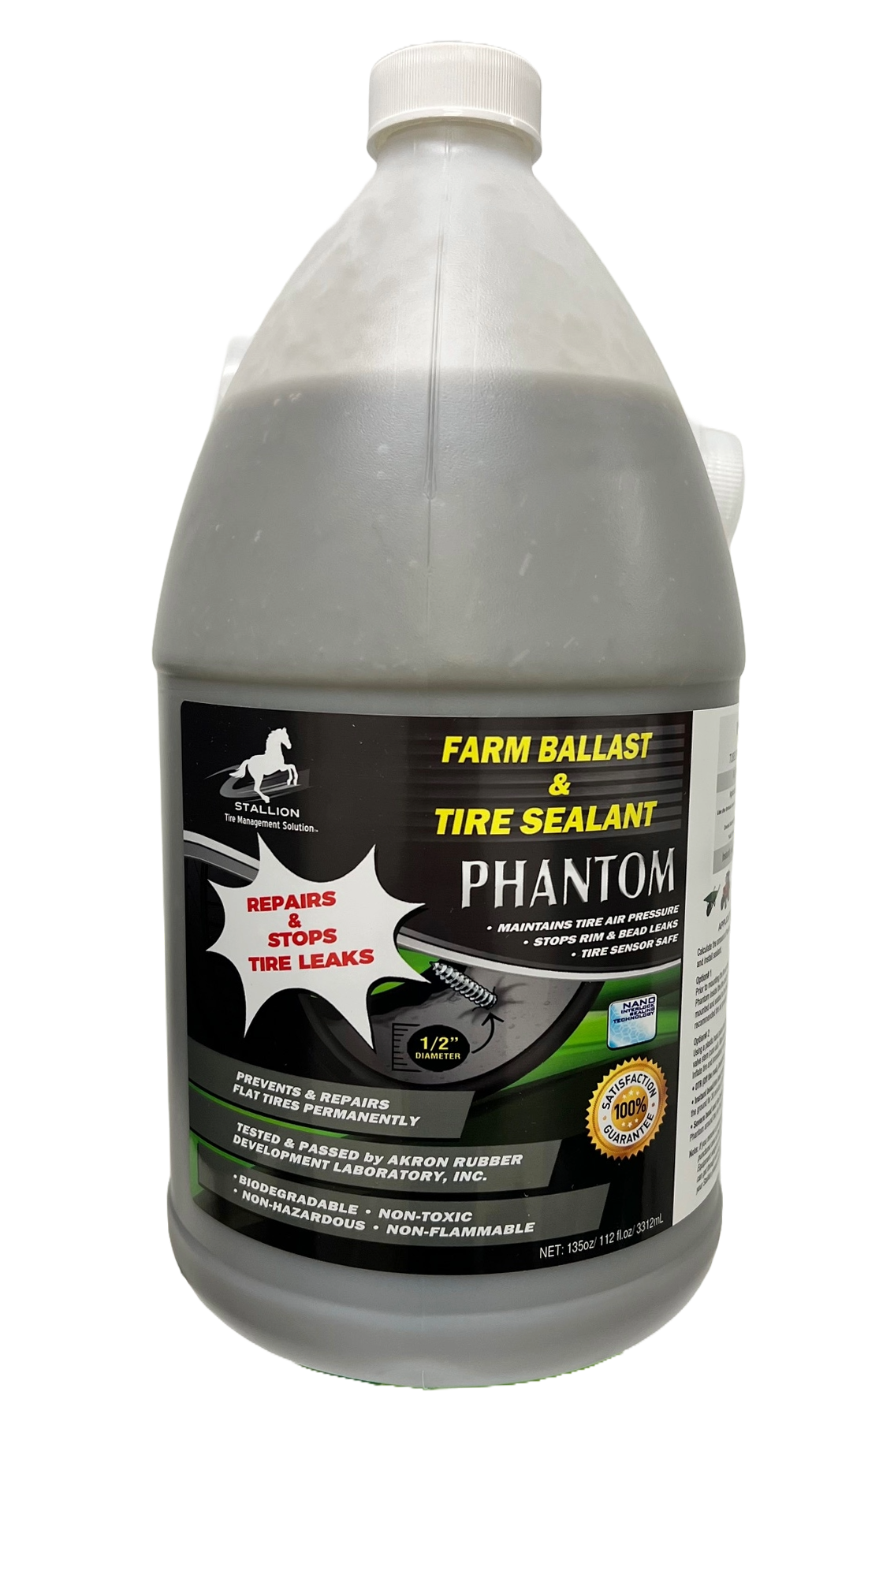
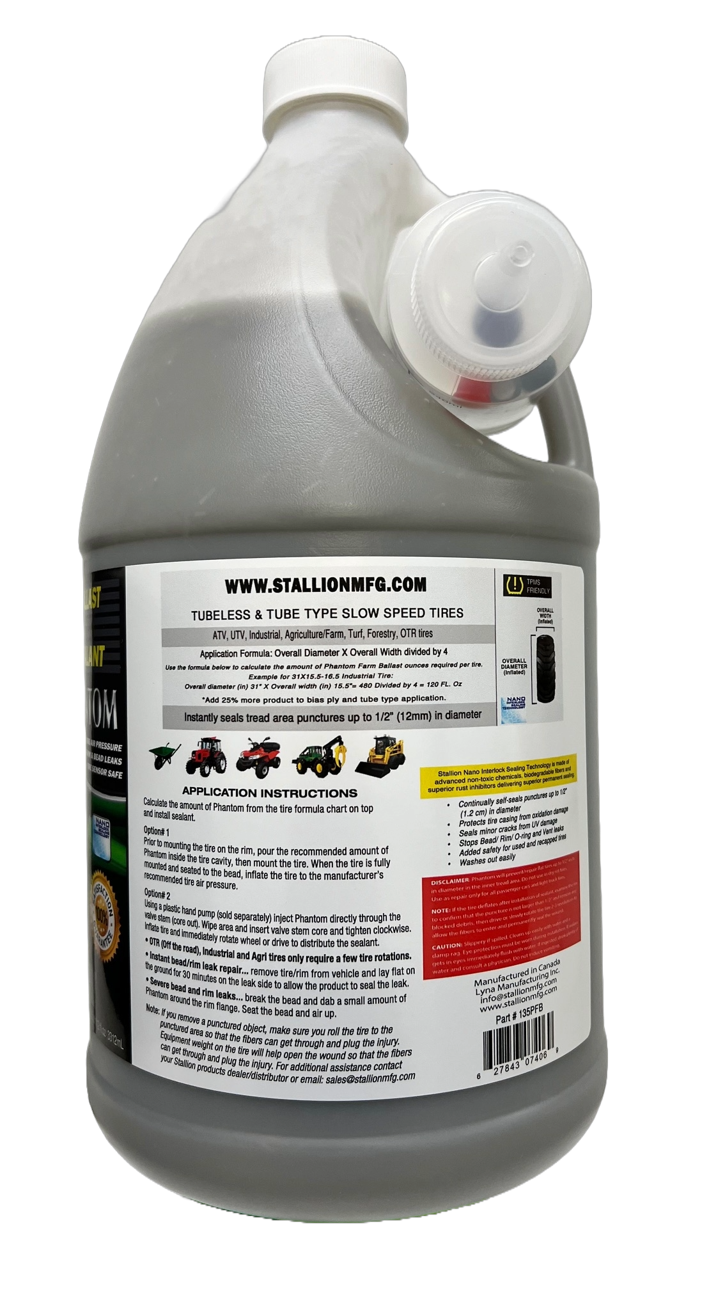
Website: http://www.stallionmfg.com

1 gallon jug, # 135PFB

5 Gallon pail, # 640PFB

